Good Afternoon delegates at the 13th Global platform for Disaster risk reduction, I really appreciate the opportunity at the last minute afforded me by Sophia Scherer to make my presentation.
The idea I will like to share with delegates is the use of social media has a tool for disaster management. Social media
is changing the way people communicate not only in their day to day lives but also in unusual circumstances such as disasters, terrorist attacks and other emergency situations. Networking sites such as Facebook and Twitter can help individuals, communities and agencies gain valuable information, share emergency and evacuation plans and establishes a line of communication between networks, a most useful tool when traditional communication infrastructures are damaged as a result of the disaster. Such as the Haiti earthquake of 2010 and the Japanese tsunami catastrophe of 2011, JAPAN TSUNAMI SOCIAL MEDIA REPORT –DR. KAREN FREBERG, UNIVERSITY OF TENNESSEE 1 JAPAN TSUNAMI CATASROPHE BRIEF REPORT 2011 is available online, a research paper on social media and the Japanese disaster.

A lot of agencies globally already have a presence on social media platforms, but using it has a tool for disaster management is still a novel idea.

Here I will like to share some of my experiences using social media at the national emergency management agency NEMA Nigeria.

We set up a Facebook account for NEMA HQ in early 2011 and also set up accounts for our zonal offices, one of the immediate impact of this, was we were able to communicate between HQ and Zonal offices in real time and very cheaply, this rapidly improved communication at the agency and allowing for synergy of information at HQ and Zonal level.

10 ways NEMA Nigeria is using Social Media

- ESTABLISH A COMMUNITY/NETWORK

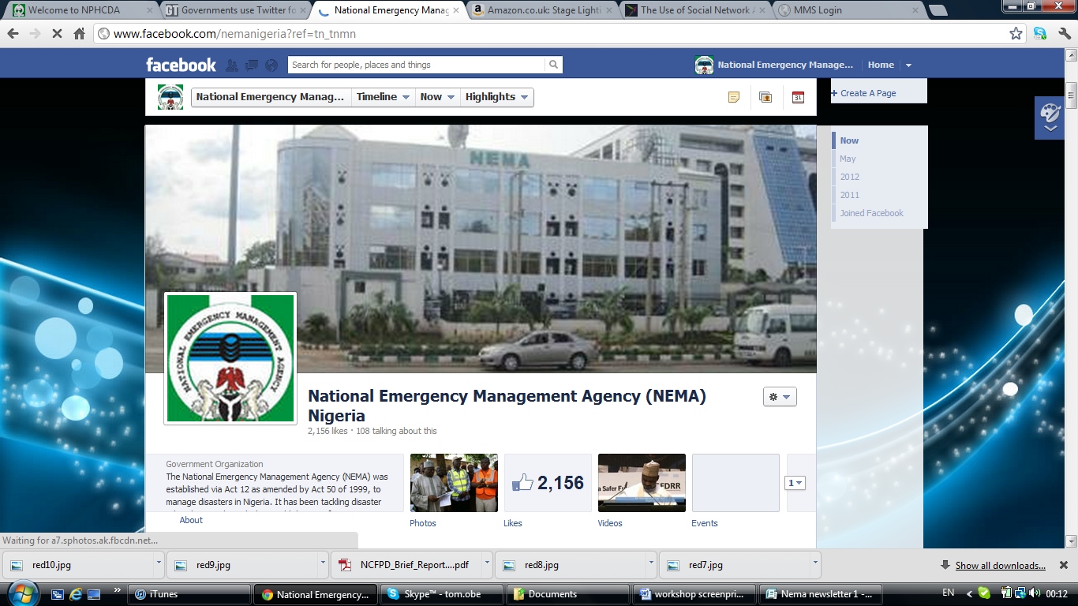
- SPREAD THE WORD

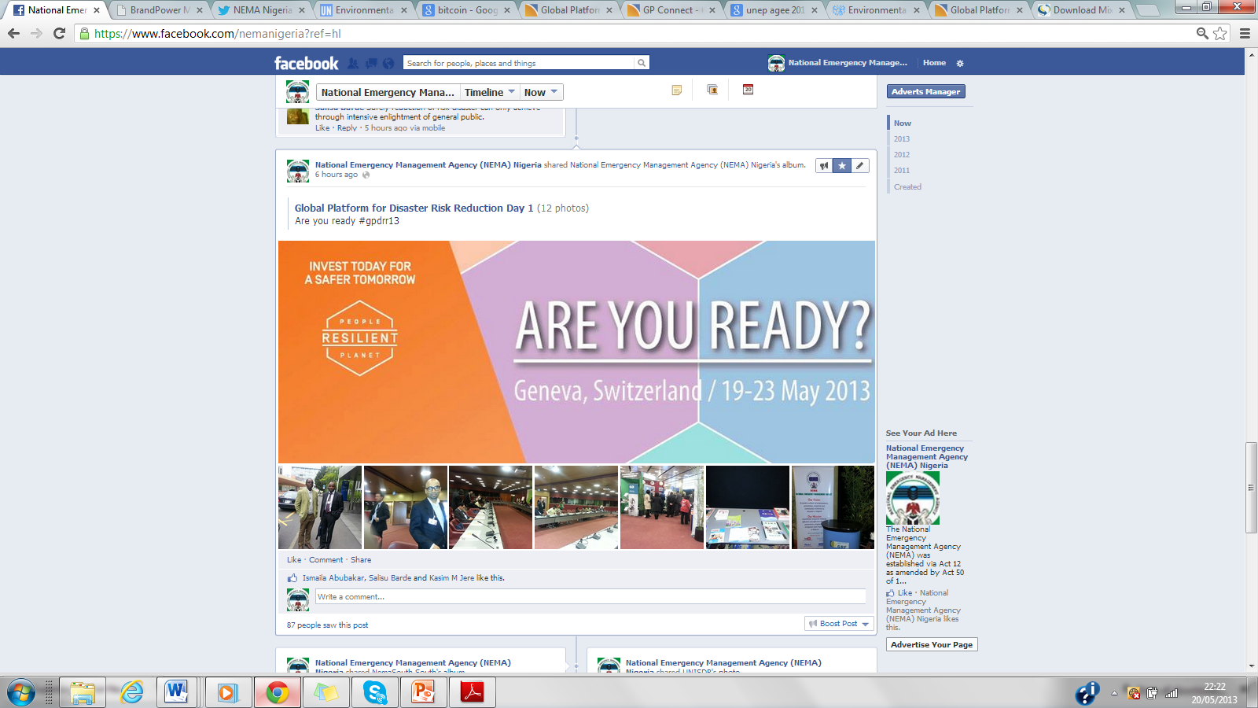
- GET ATTENTION
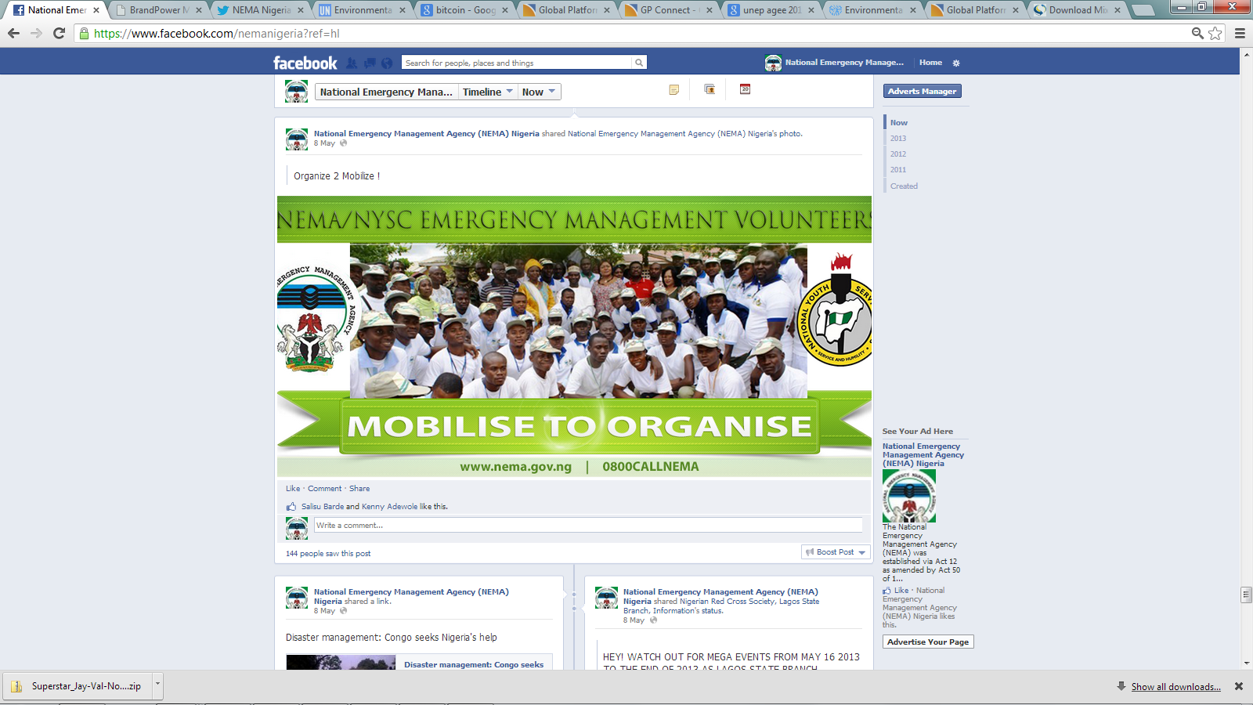
- GET FEEDBACK
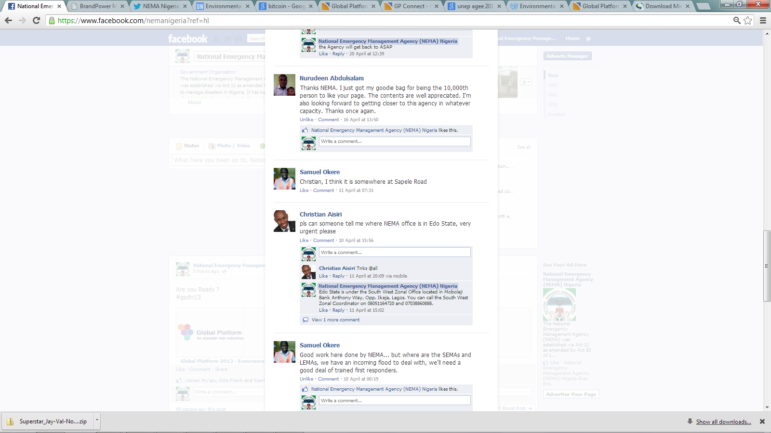
- ANSWER QUESTIONS
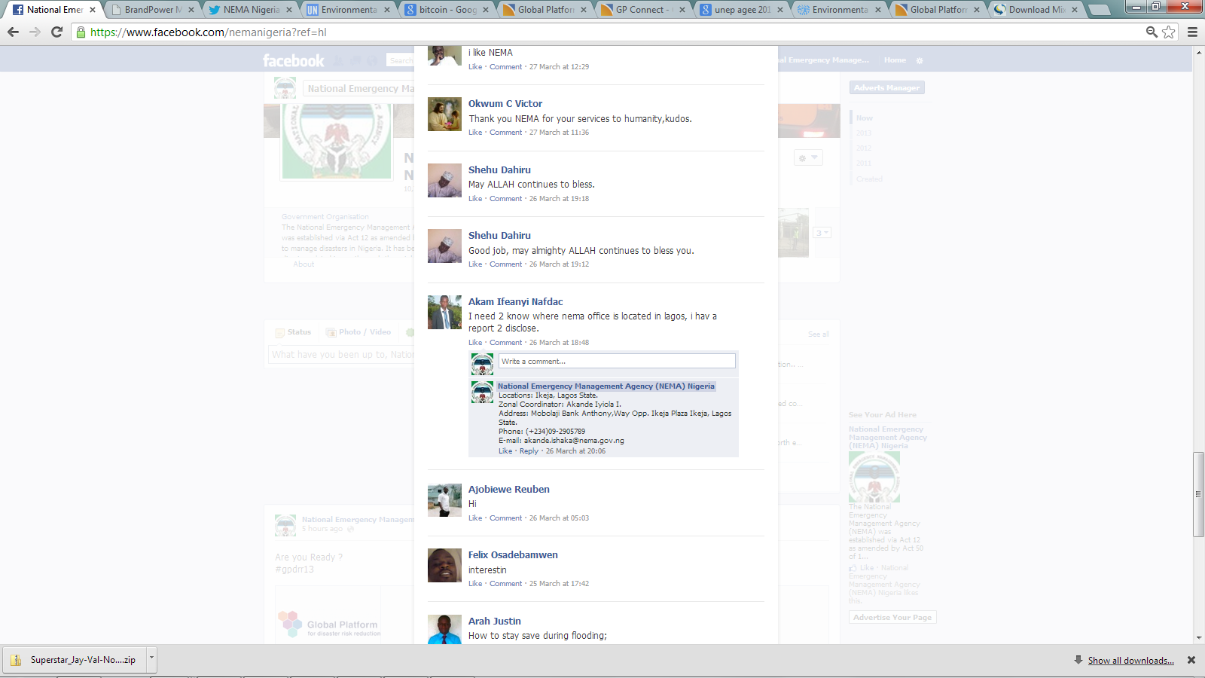
- PROVIDE SUPPORT

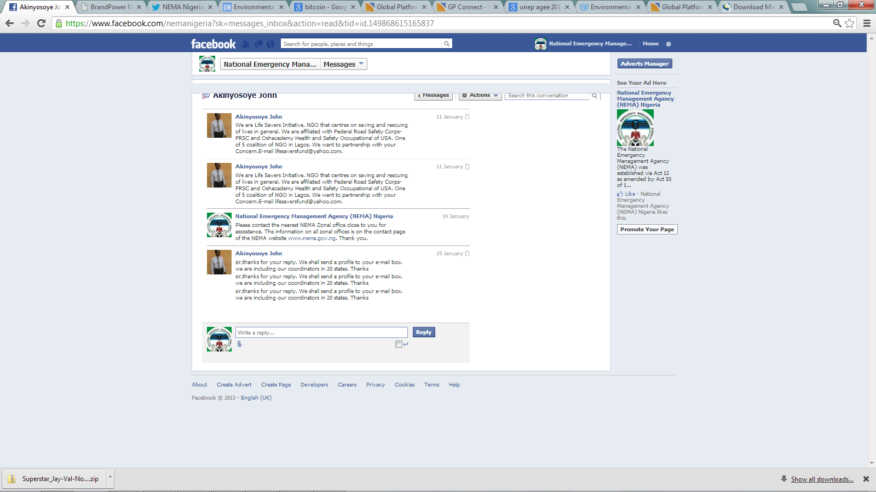
- IN EMERGENCY SITUATIONS

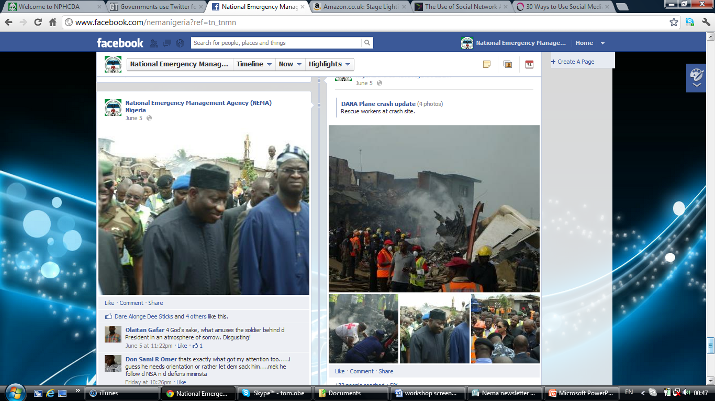
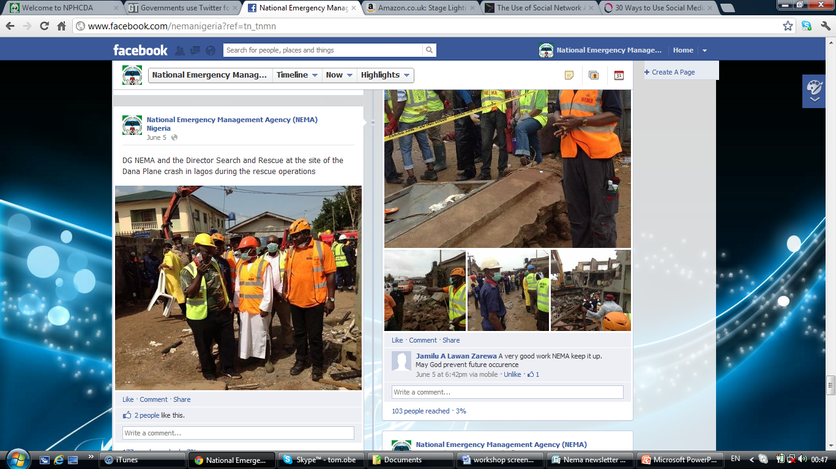
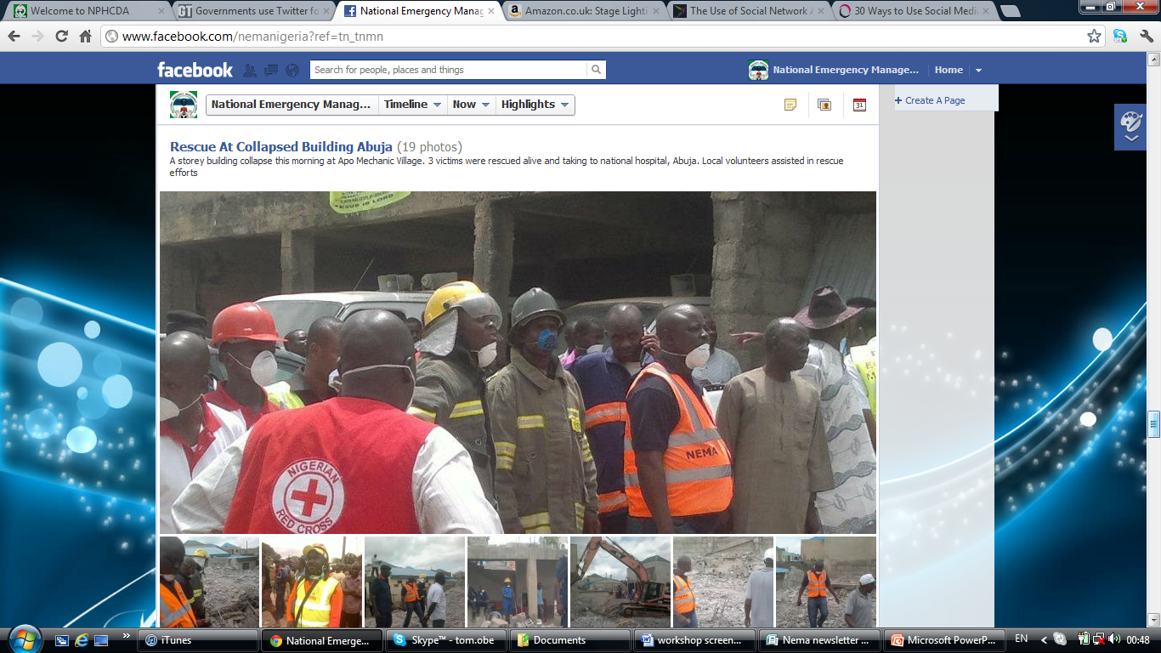
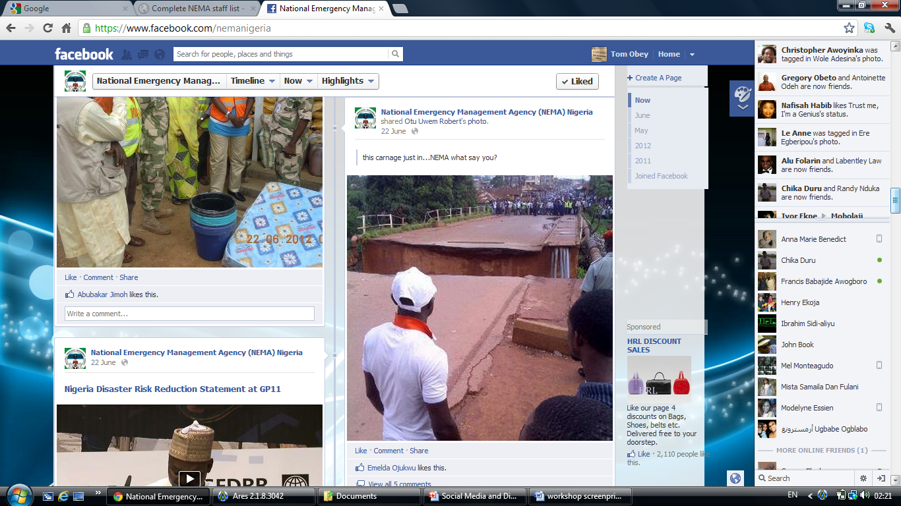
- MOTIVATE AND EMPOWER STAFF
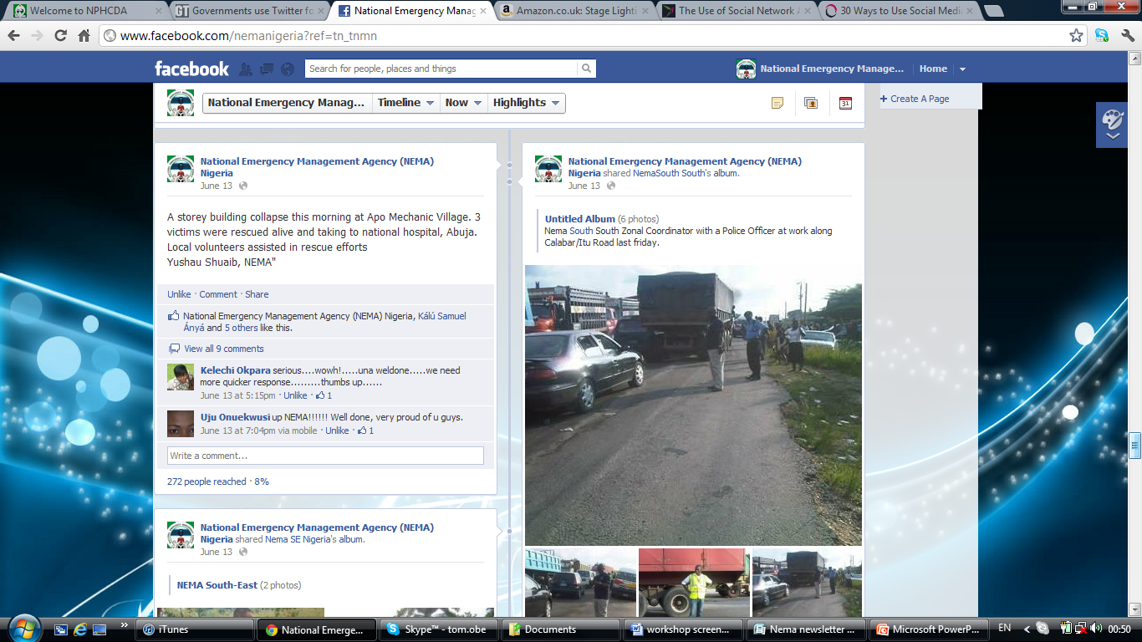
- ORGANISE
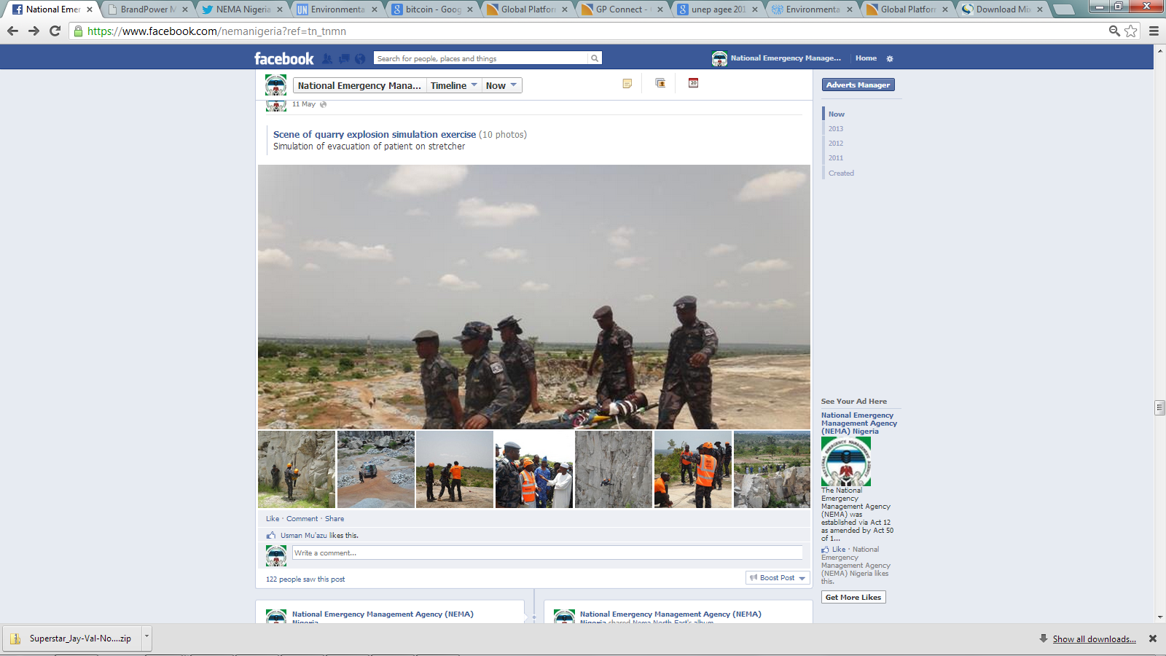
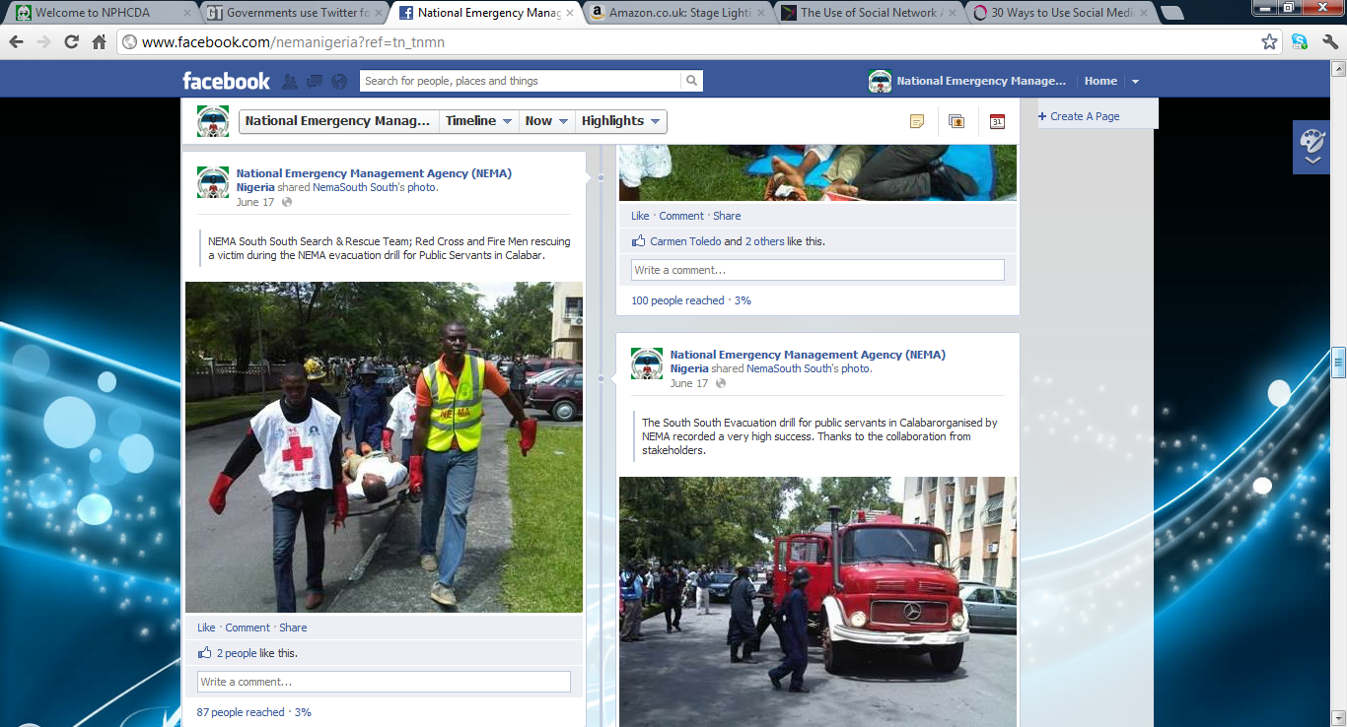
- REACH OUT / CREATE AWARENESS
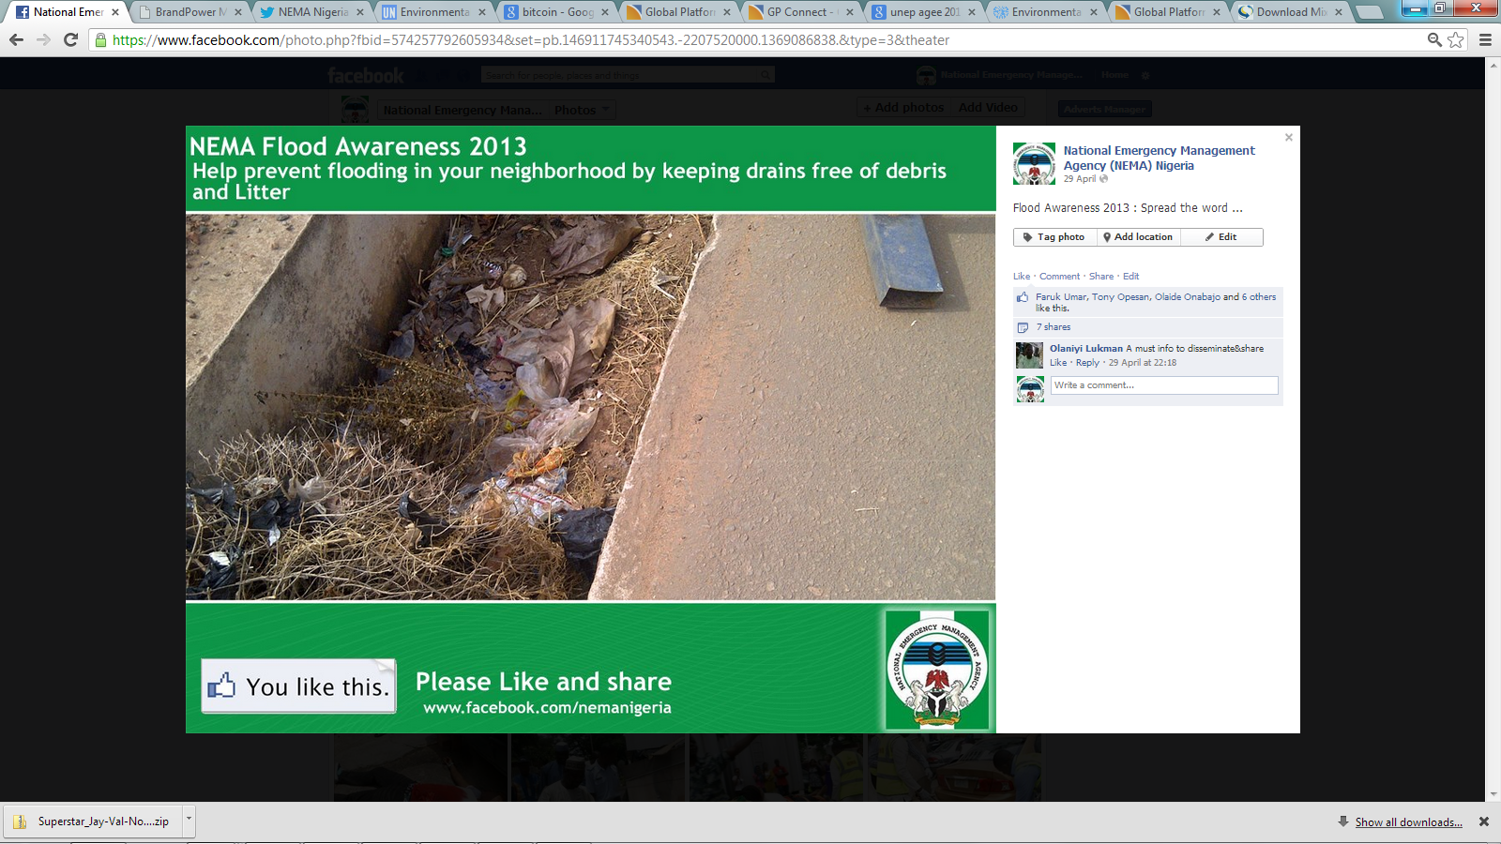
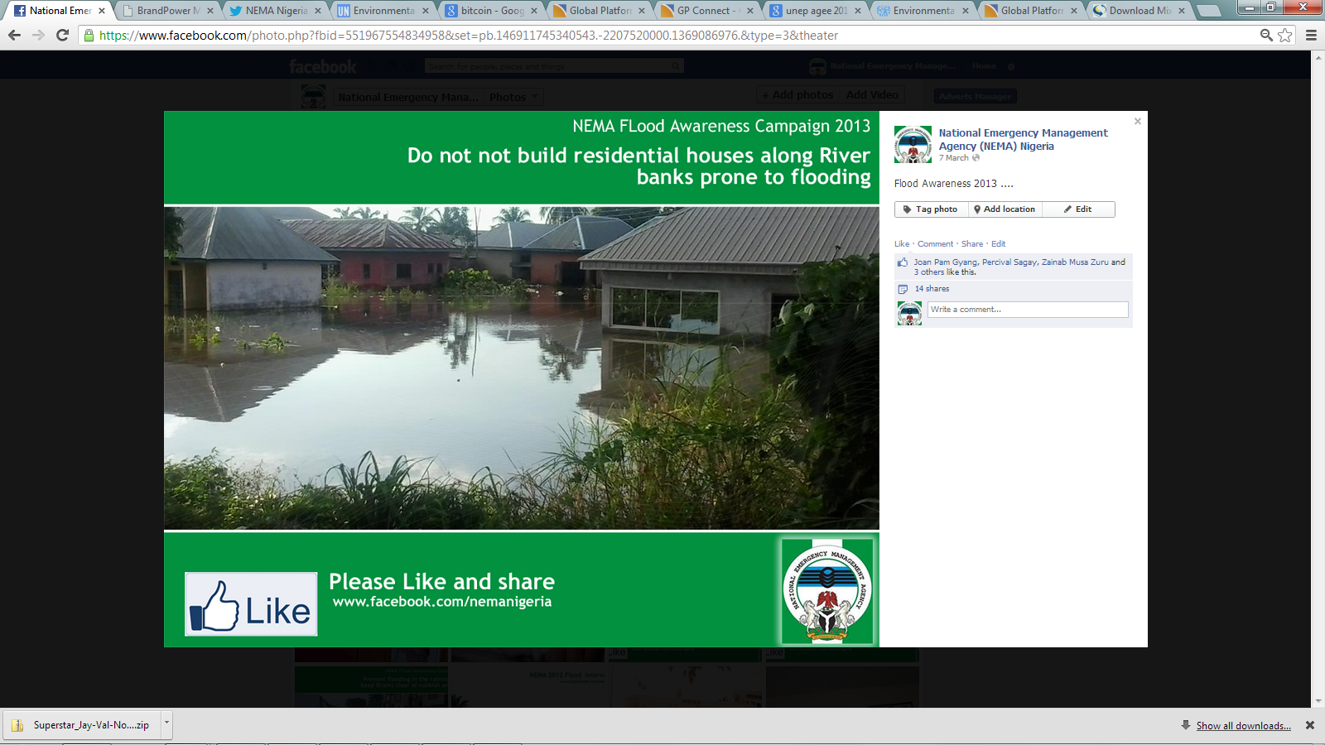
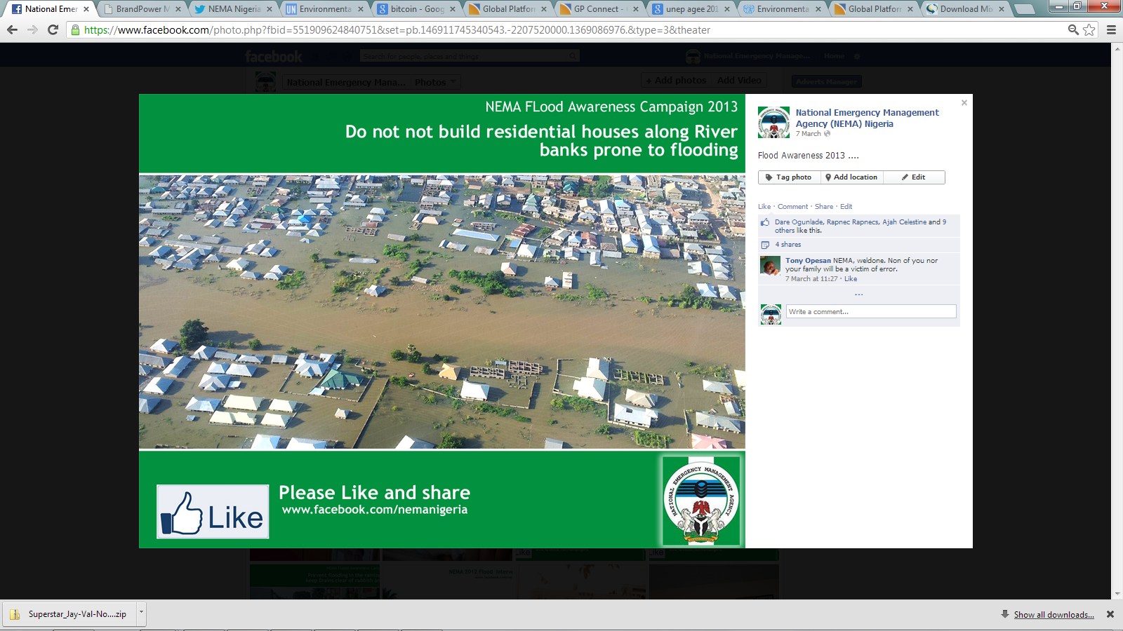
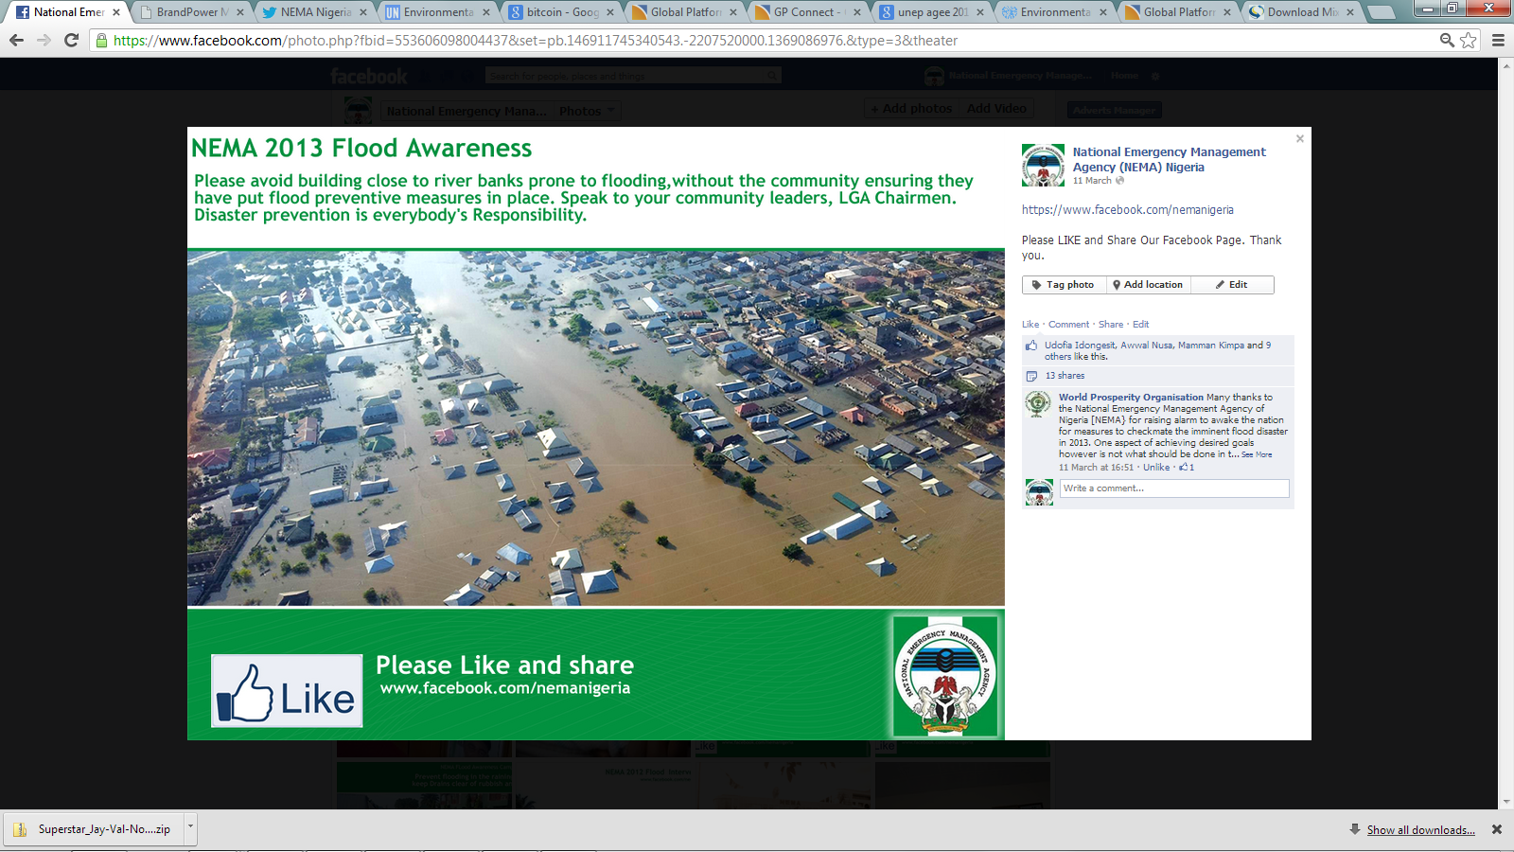
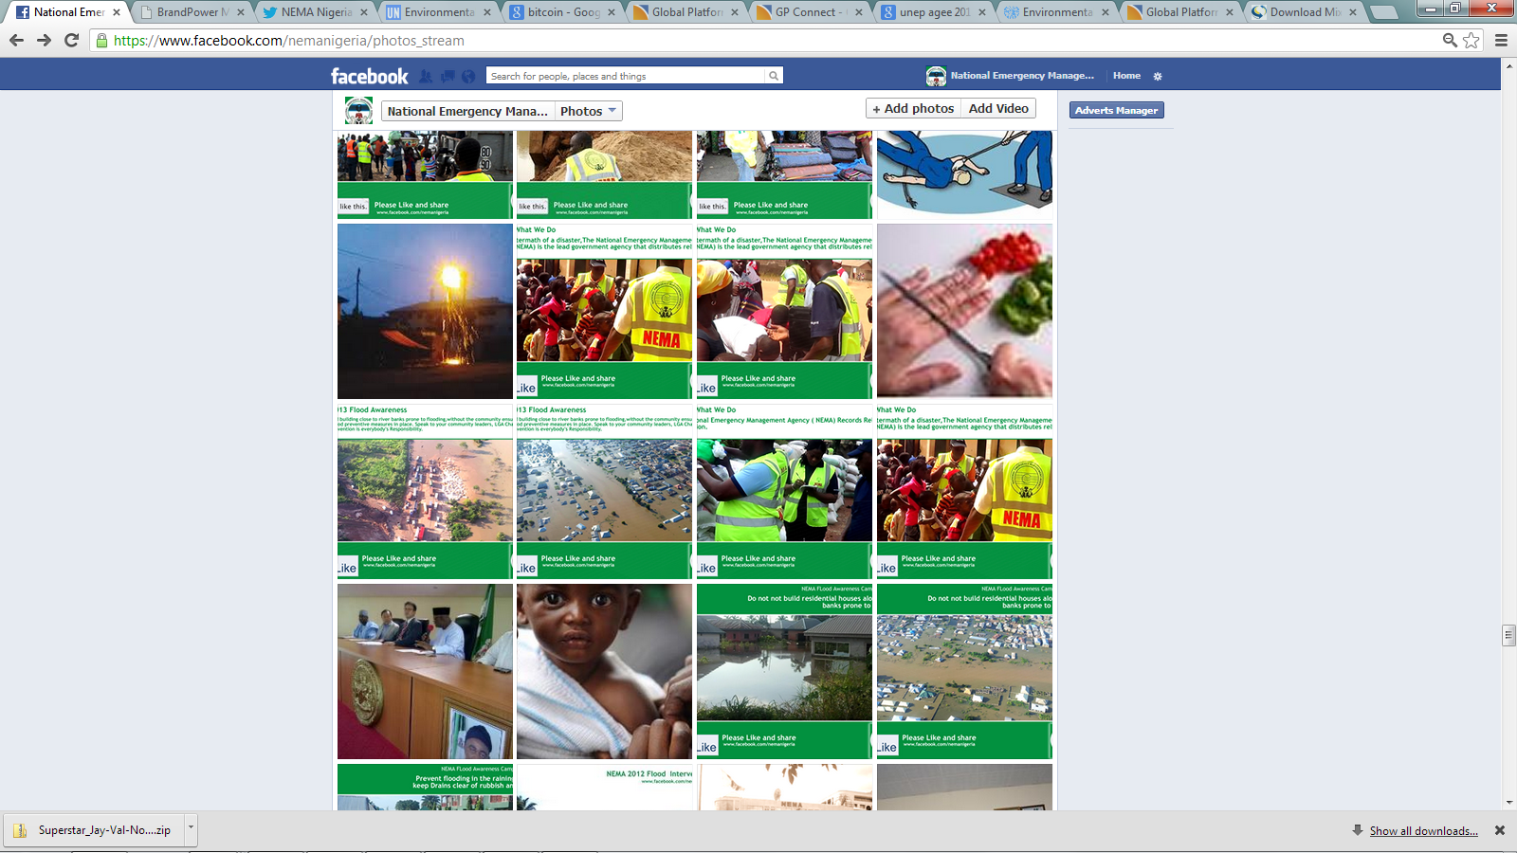
THANK YOU

www.nema.gov.ng
https://www.facebook.com/nemanigeria/photos_stream
https://twitter.com/nemanigeria
http://www.flickr.com/photos/nemanigeria/
http://www.youtube.com/user/nemanigeria

